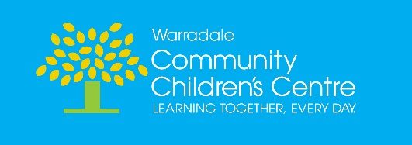
Value Statement
C
ommunity
We value our partnerships with children, families, the local community and our educators. We build relationships based on connections with people and the natural environment. Through teamwork and open communication, we build a thriving, positive, vibrant and diverse community.
H
onesty
We are honest and open in our relationships, words and actions. We are fair, truthful and sincere in our approach to all that we do.
I
ntegrity
We act professionally and with respect towards ourselves and others. We accept responsibility for our actions and take pride in doing what we say we will do. We are true to ourselves and our values at all times.
L
earning
We are passionate and enthusiastic in providing a rich learning environment for all. We strive for excellence and seek continued development as professionals. We learn alongside the children, seeing learning as a lifelong journey, embracing the opportunity to learn and grow each day.
D
iversity
We recognise that everyone has their own culture, values, beliefs and strengths, all of which contribute to our rich, vibrant and diverse community. We value each individual, working together to create a safe, lively environment where all can belong. We respect the rich culture and connection to land of Aboriginal and Torres Strait Islander people and work together towards reconciliation.

